SESNSORS FOR PROTOTYPE
- ENCODERS
OPTION 1 - Pro-Range 2500 PPR ABZ 3-Phase Incremental Optical Rotary Encoder(*Recommend*)
Price-₹ 3,972.00

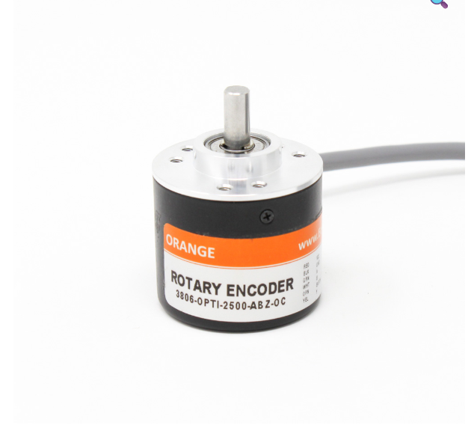
Product link - https://robu.in/product/orange-2500ppr-abz-phase-incremental-optical-rotary-encoder/
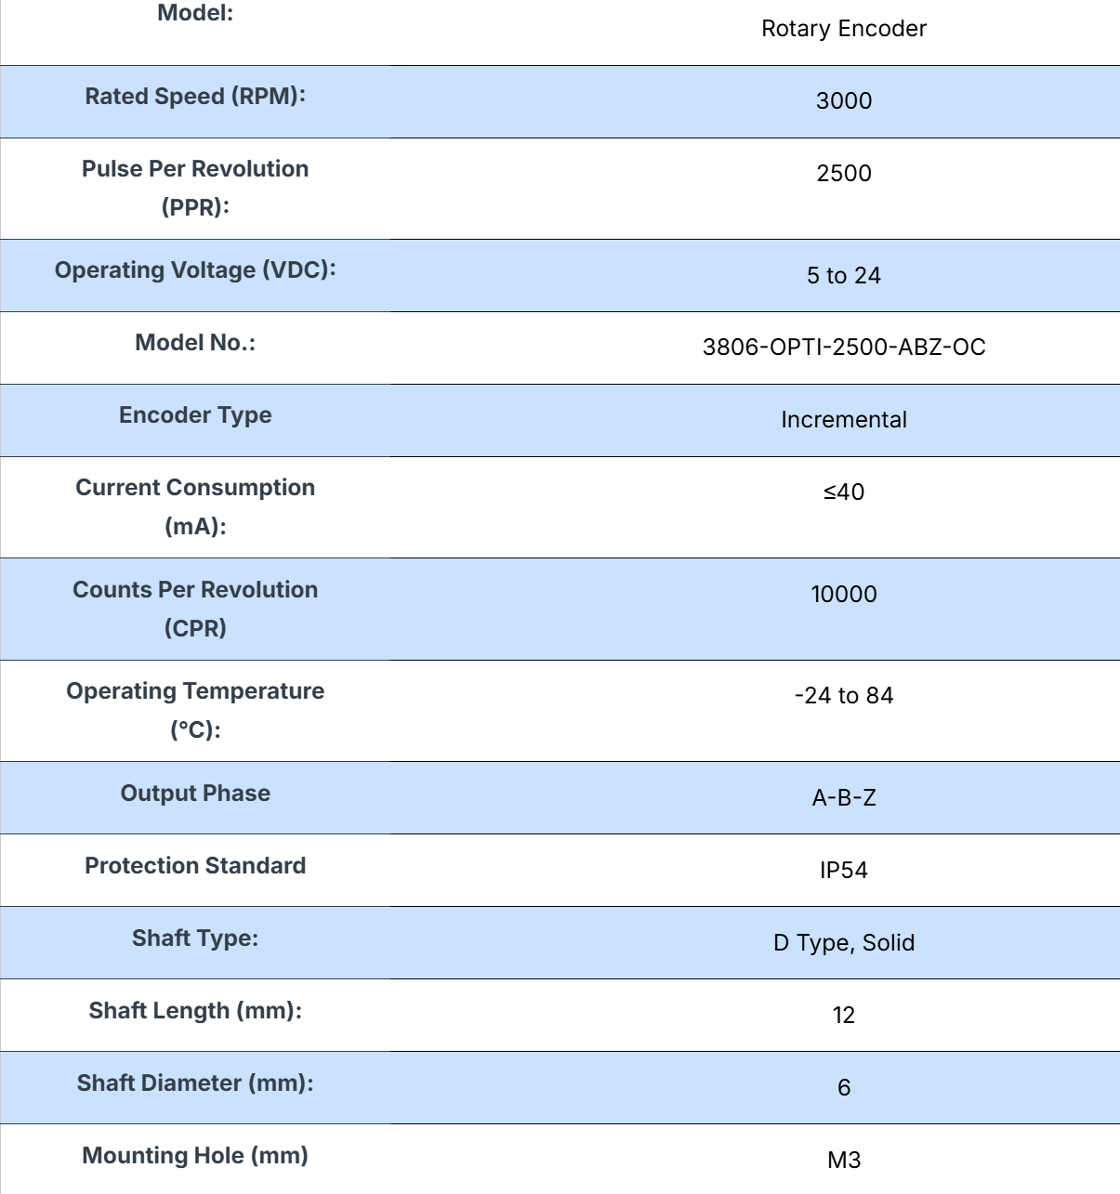
OPTION 2-Pro-Range (E38S6G5-5000Z-G24N) Rotary Incremental Encoder – 38mm, Photoelectric, ABZ 3 Channels (FIRST CHOICE)
PPR -5000
Price- Rs.2422
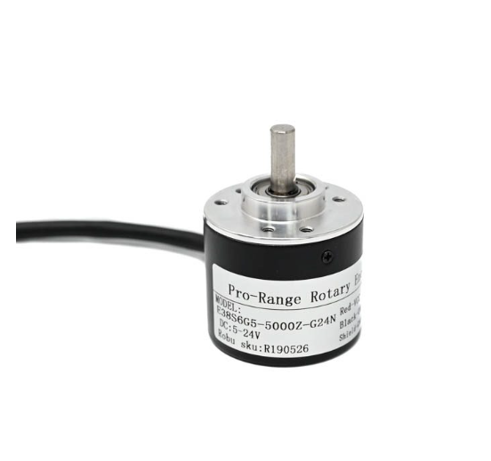
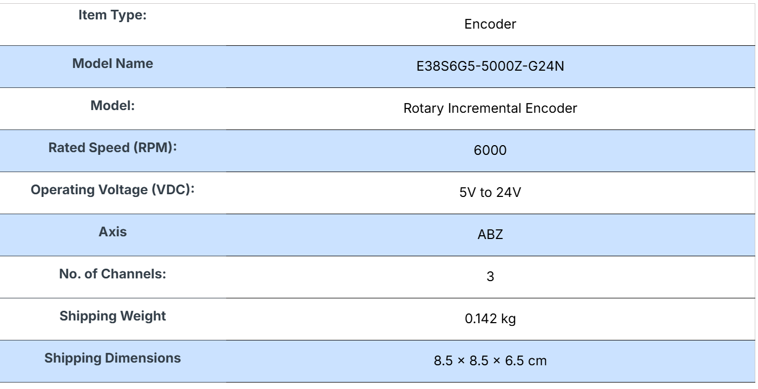
Product link - https://robu.in/product/pro-range-rotary-incremental-encoder-38mm-photoelectric-abz-3-channels-5000-ppr-e38s6g5-5000z-g24n/#tab-specification
Datasheet- https://robu.in/wp-content/uploads/2024/12/E38S6-1.pdf

- CAMERAS
Option 1 - ZED 2i Stereo Camera * SAME ONE IS USED BY IITB*(FIRST CHOICE)
Price-529 USD (including shipping)

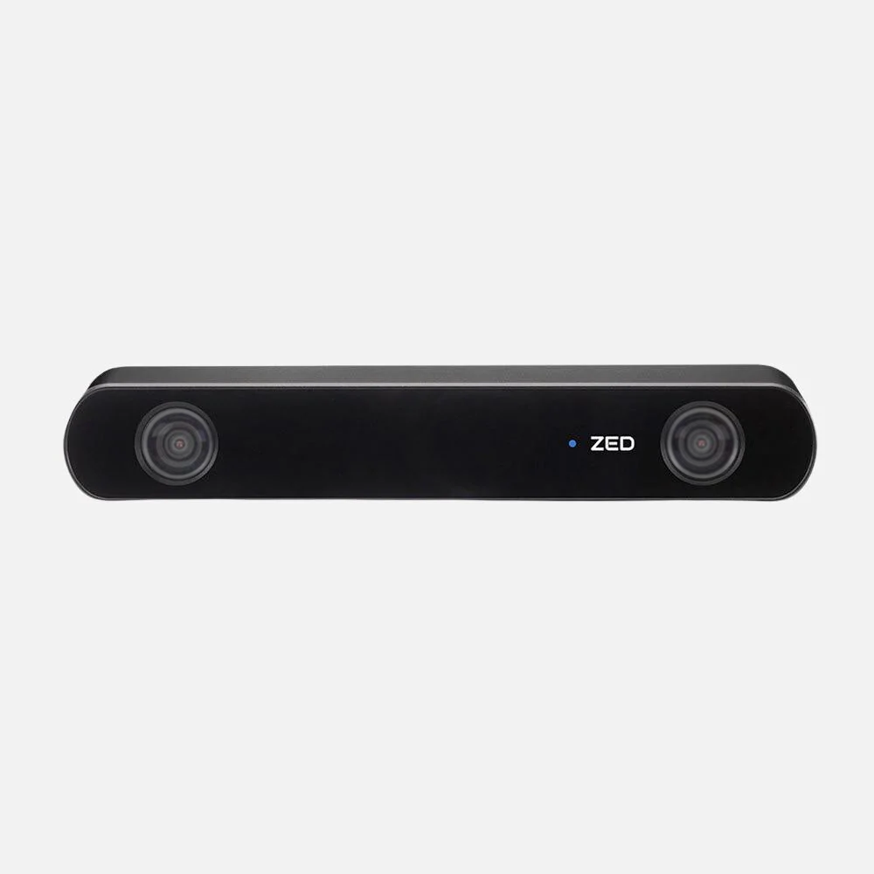

- Dual high-resolution RGB sensors with a wide 110° field of view.
- Integrated IMU, barometer, magnetometer, and temperature sensor for robust environmental awareness.
- Neural depth engine enabling precise obstacle detection and 3D mapping.
- Modular design with interchangeable lenses and an optional enclosure for IP66 protection.
- Compatible with NVIDIA Jetson and other edge platforms.
- Ideal for autonomous navigation, object tracking, spatial analytics, and mixed-reality
- Neural Depth Sensing
- Spatial Object Detection
- Built-in Next-Gen IMU, Gyroscope, Barometer & Magnetometer
- 120° Wide-Angle FOV
- All-Aluminium Frame with Thermal Control
- Optional Integrated Polarizer for reflection removal
- IP66 protection from water and dust
- Secure USB Type-C connection

*MORE DETAILS ARE AVAILABLE ON THE WEBSITE*
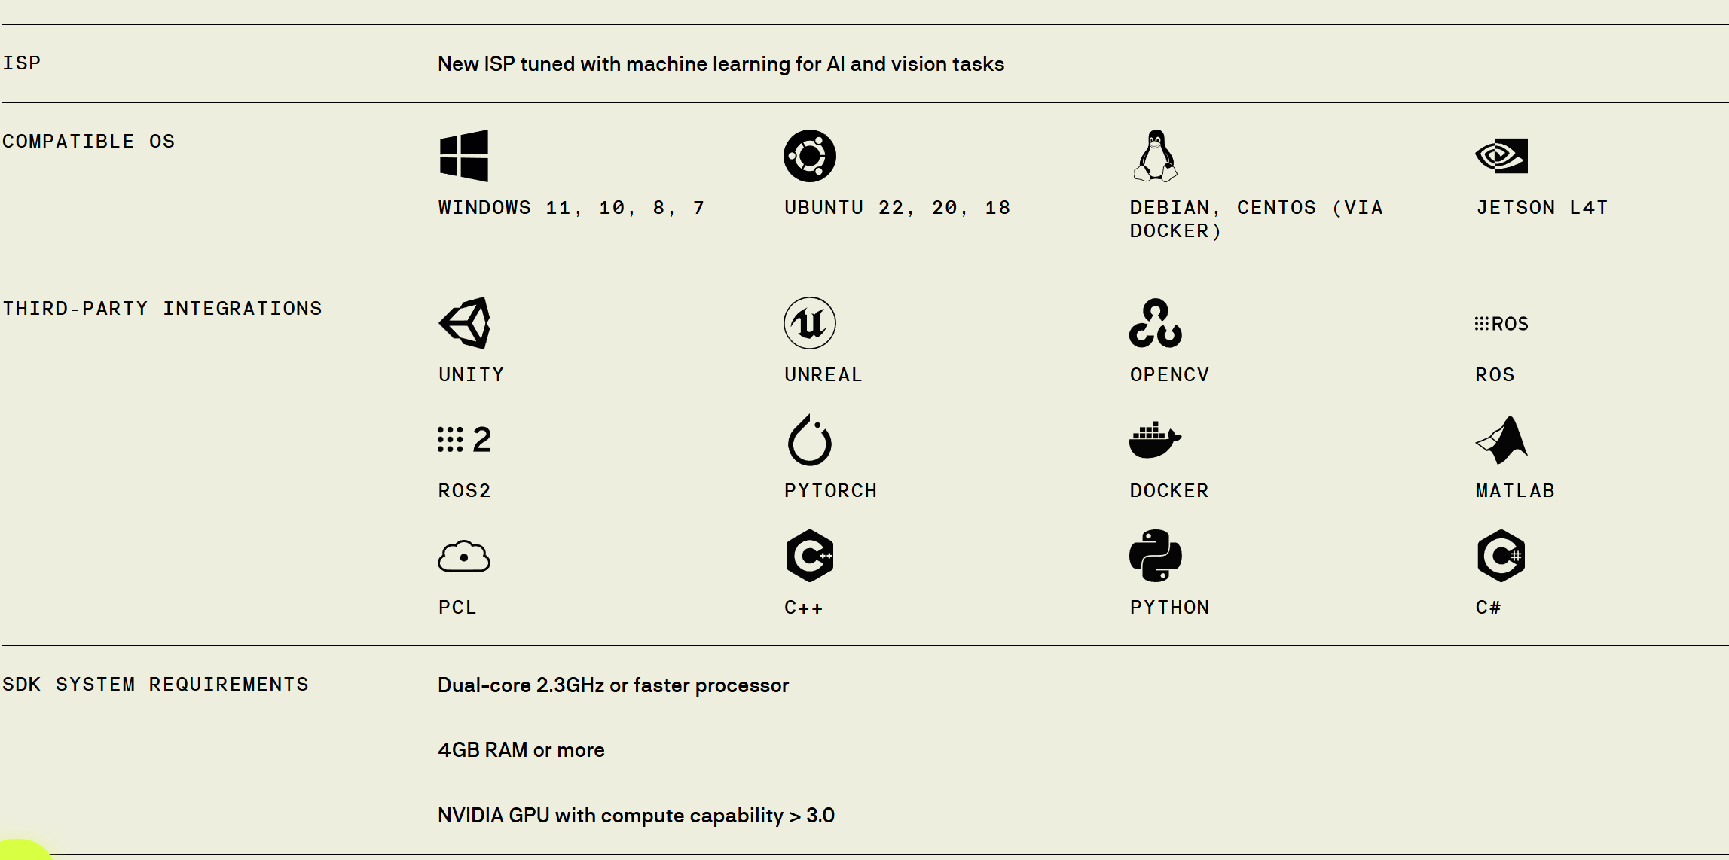

DATASHEET-https://cdn.sanity.io/files/s18ewfw4/staging/c059860f8fe49f3856f6b8da770eb13cc543ac2c.pdf/ZED%202i%20Datasheet%20v1.2.pdf
PRODUCT LINK -https://www.stereolabs.com/en-in/store/products/zed-2i

OPTION 2 - Stereolabs ZED Mini Stereo Camera
PRICE-429 USD (INCLUDING SHIPPING)
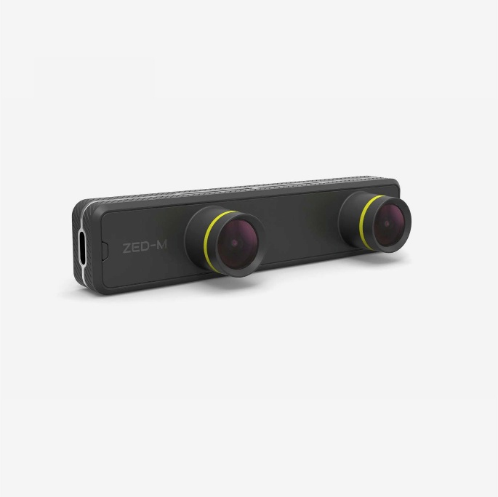
Product Features
- Built-in 6DoF IMU for accurate motion tracking.
- HD depth sensing with new Ultra mode.
- Small form factor with 6.5cm eye separation.
- Aluminium frame for improved robustness and integration.
- USB Type-C for high-speed data transfer and improved reliability.
- ZED SDK for application development.

System Requirements for SDK
- Dual-core 2.3GHz or faster processor
- 4 GB RAM or more
- USB 3.0

System Requirements for AR
- Quad-core 3.0GHz or faster processor
- 8 GB RAM or more
- NVIDIA GTX 2070 or higher

DATASHEET-https://cdn.sanity.io/files/s18ewfw4/staging/ebcd46896092d1ee6212b7f4d81aaa1c479c2440.pdf/ZED%20Mini%20Datasheet%20v1.1.pdf
PRODUCT LINK- https://www.stereolabs.com/en-in/store/products/zed-mini
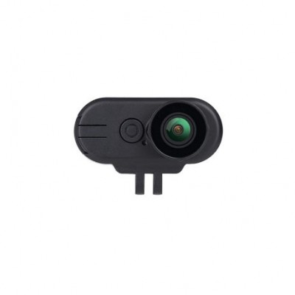
Hawkeye Thumb 4K
*CAN BE USED ALONG WITH THE STEREO CAMFOR MONOCULAR VISION PIPELINE ALSO CAN BE PURCHASED WHICH IS SAVED ON ZED MINI *
PRICE - Rs.6604.00

PRODUCT LINK- https://www.electropi.in/hawkeye-thumb-4k

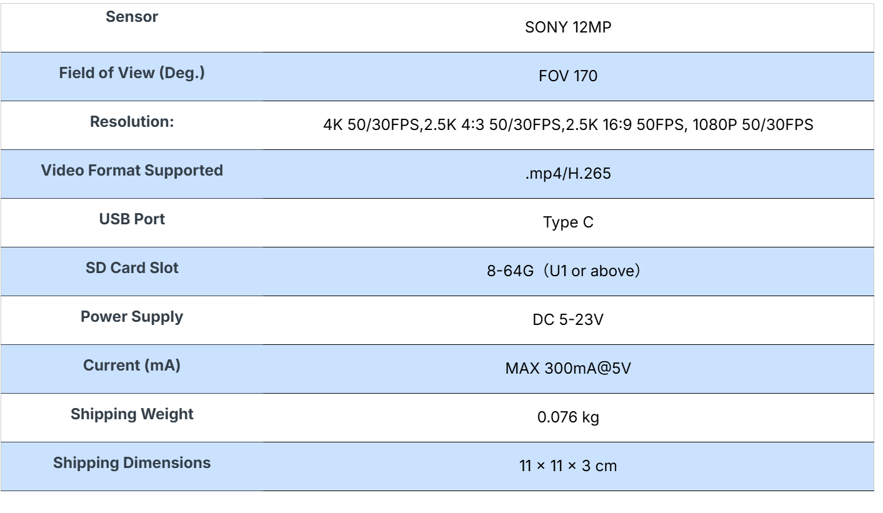

Option 3 -Orbbec Gemini2 Stereo 3D Depth Camera Advanced Imaging for AR/VR
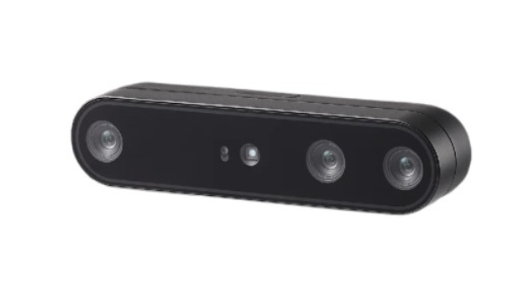
Price -₹ 30,602.00
- Global shutter for RGB and IR cameras
- Wide field of view at 91° horizontal and 66° vertical
- High quality depth data output from 0.82 to 32.8′
- Up to 60 fps at 640 x 400 and 30 fps at 1280 x 800 depth resolutions
- USB-C for power and data connectivity
- Internal MIU
- Multi-camera synchronization and IMU supported

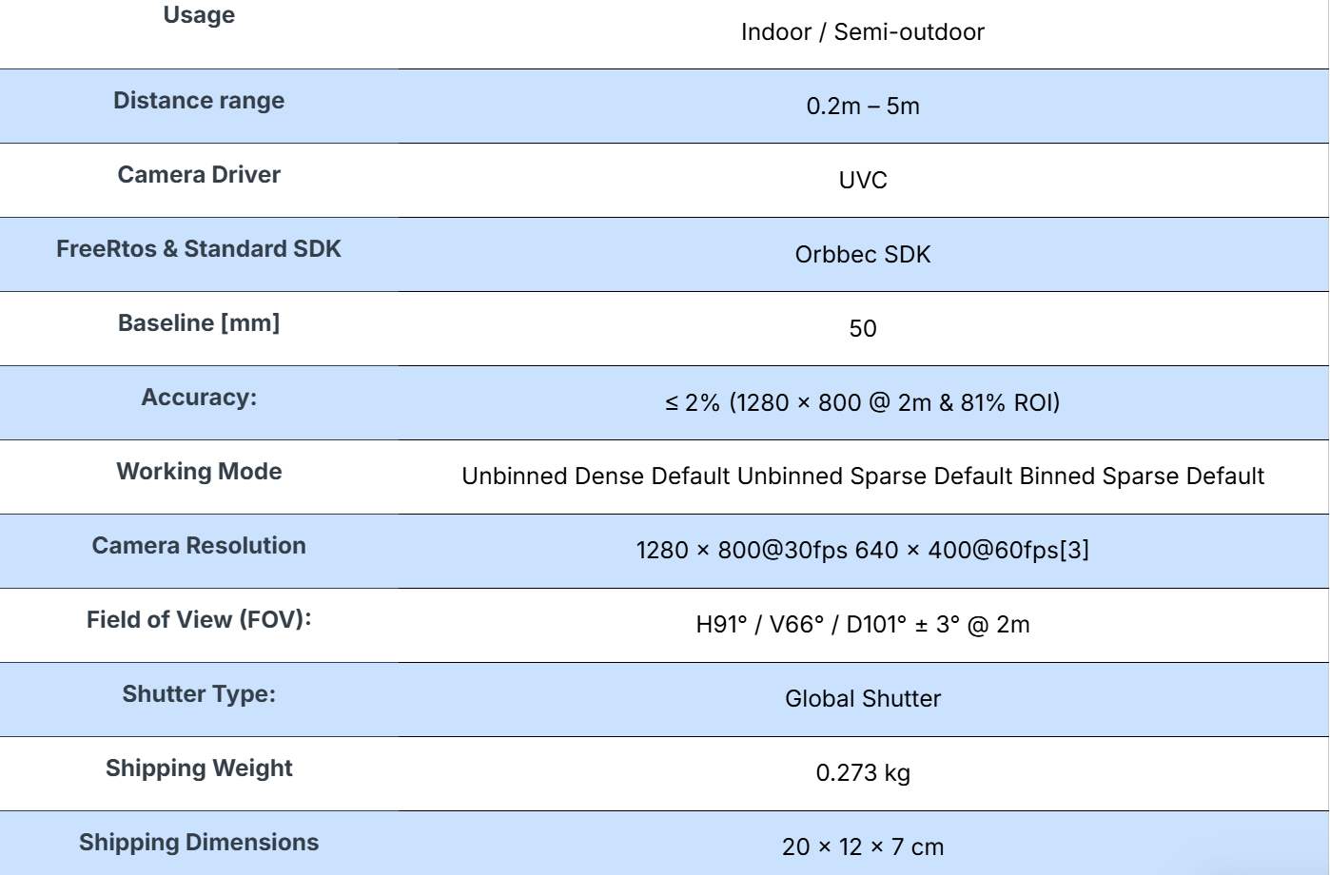

Product link- https://robu.in/product/orbbec-gemini2-sereo-version-3d-camera/
- LiDAR
Option 1- Velodyne Puck lidar sensor
Price – ₹ 483,435.00
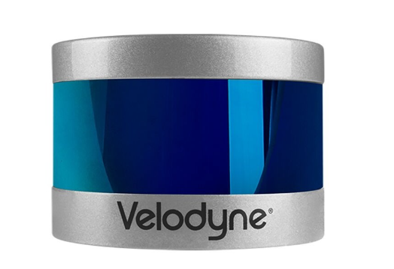

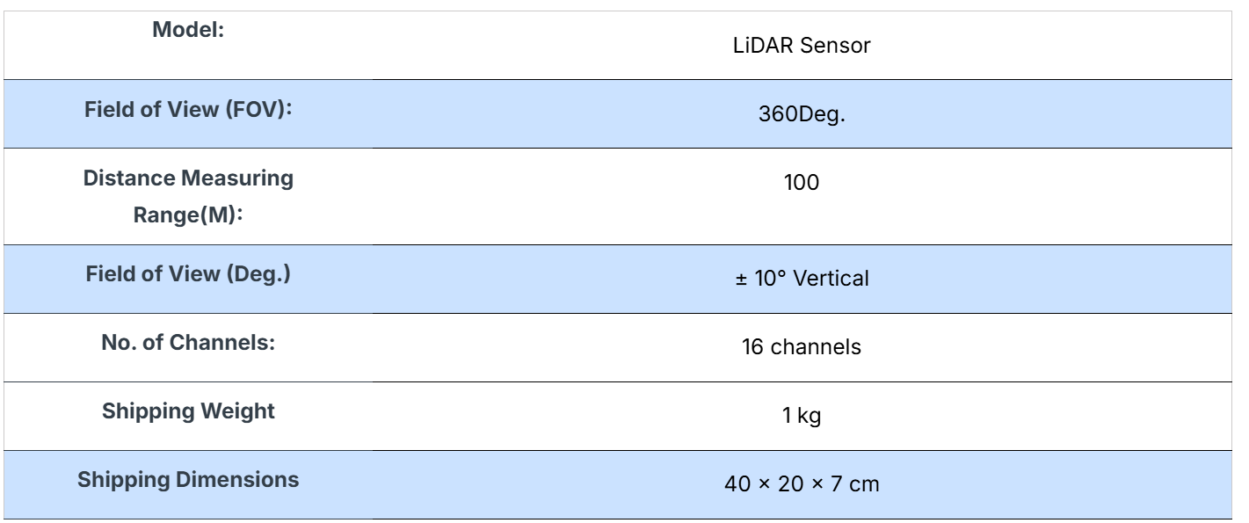

Product link – https://robu.in/product/velodyne-puck-lidar-sensor/#tab-specification
DATASHEET - https://robu.in/wp-content/uploads/2022/06/Puck__Datasheet_whitelabel.pdf

OPTION 2 - HESAI JT16 Mini 360° x 40° 3D Lidar
PRICE -₹ 136,800.00
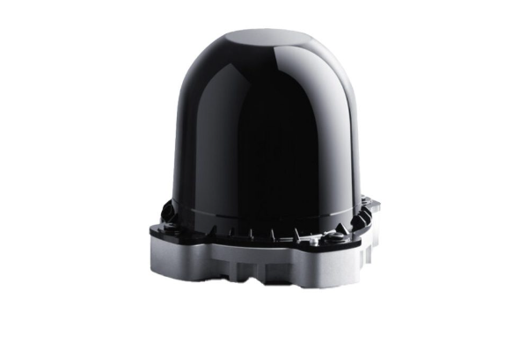
- 70% smaller than standard models
- 360° x 40° FOV, enhanced spatial perception
- 30m range at 10% reflectivity, 100m max range
- Built-in IMU for precise motion tracking
- IP6K7 & IP6K9K-rated
- Lightweight (<200g) and low power (4.3W) consumption

Product link – https://robu.in/product/jt16-mini-360-x-40-3d-lidar/#tab-product_download_66939_tab
Datasheet – https://robu.in/wp-content/uploads/2025/02/R208526-JT16_User_Manual_J03-en-250120.pdf

Option 3 - Unitree 4D LiDAR L2
PRICE -₹ 53,793.00
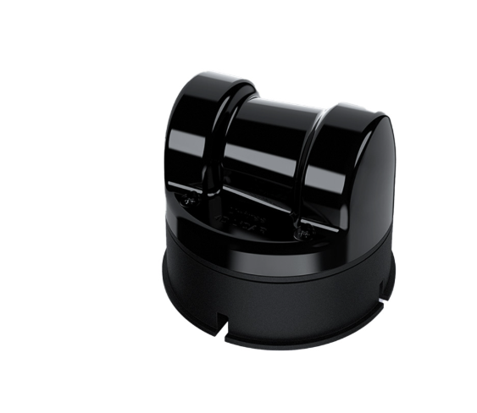

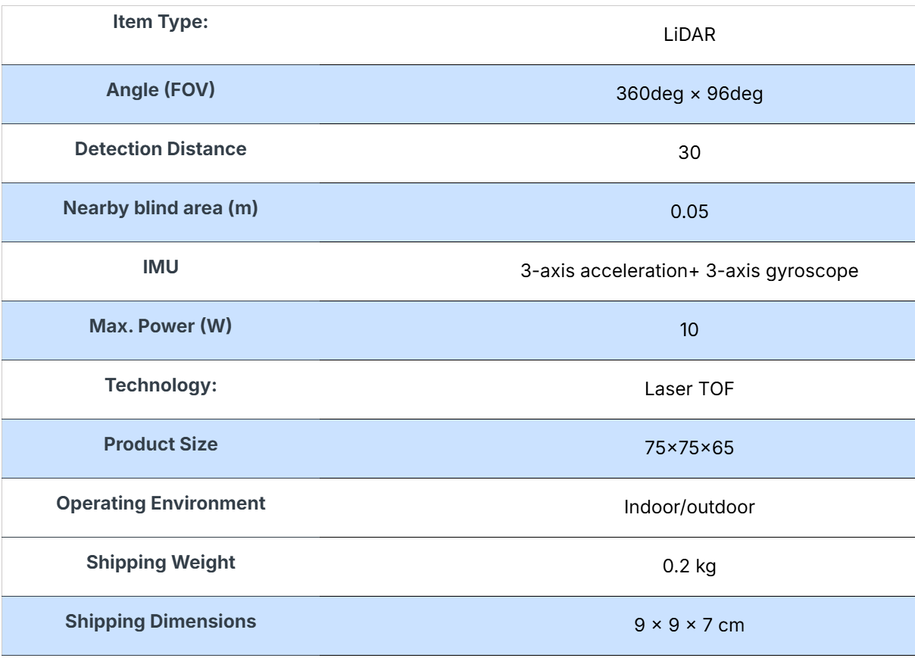
Product link - https://robu.in/product/unitree-4d-lidar-l2/#tab-description
Datasheet - https://robu.in/wp-content/uploads/2025/01/R202625-4D-LiDAR-L2.pdf

Option 4- Hesai Pandar40P 40-Channel 360° Spinning Long-Range Lidar
Available on eBay
Price-250 USD
PRODUCT LINK - https://ebay.us/m/e90vFS

